Form B
Business Case for the Approval of a New Partnership Arrangement

This form should be completed as part of the first stage approval process when developing a partnership with another organisation.

In accordance with the Terms of Reference of the Due Diligence Panel (DDP), a partnership is:

‘where the achievement of the learning outcomes for a module or programme are dependent on arrangements made with (an) other delivery or support organisation(s)
or
‘where the learning opportunities leading or contributing to the award of academic credit or a qualification are delivered, assessed or supported through an arrangement with one or more organisations other than the University of Liverpool’

This Form B will require scrutiny by and endorsement from the DDP and then approval from the Senior Leadership Team (SLT). The purpose of this form is to determine if there is a viable business case for the proposed arrangement and proceeding to the next stage of approval. This Form B may be submitted to the DDP together with Form A, which is the New Partner Proposal and Due Diligence Form, or it can be submitted after Form A has already been submitted to the DDP and SLT and given interim approval subject to consideration and approval of this Form B.

Please provide the following information and submit it along with the full costings.

NB: this Business Case should be based on a five-year financial plan, as agreements for collaborative arrangements are normally established for five years.

NAME OF PROPOSED PARTNER

ADDRESS

PARTNER CONTACT DETAILS

STRATEGIC-LEVEL DEVELOPMENT  (i.e. initiated at institutional level) |  | YES | NO
 |  | ☐ | ☐

NAME OF PROPOSER: (or nominated key contact)

DEPARTMENT:

SCHOOL/INSTITUTE:

FACULTY:

SECTION ONE

THE PROPOSAL

1.1 The institution(s) or organisation(s) to be involved
Please list the institution(s) to be involved in the proposed arrangement and detail what their role will be:

1.2 Programme(s) and award(s) involved
Please complete the table below about the programme(s) and award(s) to be covered by the proposed arrangement:

Type or description of proposed arrangement:

Award (e.g. undergraduate degree, master’s degree, etc.)

Name of programme(s):

Is the programme(s) new?

If the programme(s) already exists, will changes be required to it for the proposed arrangement? If so, please explain the changes

Is the programme(s) subject to professional, statutory or regulatory body (PSRB) recognition? If so, will approval from the PSRB be required?

Structure of the programme(s) under the proposed arrangement:

Mode of delivery of the programme(s):

Proportion of credit for the award assessed by UoL:

Proportion of credit for the award assessed by the partner organisation(s) that will contribute to a UoL award:

Proposed links with partners in China must first be considered by the XJTLU Joint Liaison Group. Please confirm that this proposal has been notified to the JLG and discussed with XJTLU.
What were the outcomes of the discussions?

1.3 Likely timescale for introduction

What is the expected start date for students on the provision covered by the proposed arrangement?

At which partner organisation will the students commence their programme of studies?

Where students commence their studies at a partner organisation and complete their studies at the UoL, what is the expected start date at the University of Liverpool?

1.4 Management and administration implications
Please complete the table below to provide information to inform the implications for the management and administration of the proposed arrangement.

Proposed Link Tutor(s) at UoL:

Number of expected students each year:

Minimum number of students required each year:

What is the maximum number of students that can be accommodated each year under the arrangement?

Resource implications for the School and the University to set up, manage, monitor and review the arrangement and potential income in the first five years (supported by a completed costing model, as per Appendix 1)

1.5 Rationale

What is the rationale for the proposed arrangement?

How will UoL benefit from the proposed arrangement?

What can be offered under the proposed arrangement that cannot be offered by UoL itself?

What market research has been undertaken?

What were the results of the market research?

Who undertook the market research?

1.6 Marketing and promotion

What is the marketing and promotion plan for the first cohort of students?

What is the marketing and promotion plan for the lifetime of the proposed arrangement?

Who will responsible for marketing and promoting the provision offered under the arrangement? How will this be managed?

1.7 Additional information
Please enter below any additional information about the proposal that has not been covered above:

SECTION TWO

BENEFIT/COST SUMMARY

This summary will be used as a basis for the full costing to be undertaken, (See appendix 1 for costing parameters to be used and to support consideration of potential costs).

2.1 Benefits
Please complete the tables below. Please add additional lines as necessary.

Educational:

> innovation

> alignment with research (new or existing)

> attract new students

> response to changing curricula

> professional needs

Add more lines if necessary

Financial:

> fees
Please note that any non-standard fee arrangements must be approved by the Student Intake Strategy Group
> special sources of funding (RCUK, NHS, charities, industry, etc.)

> travel and subsistence costs for visiting the partner

Add more lines if necessary

2.2 Costs

Staffing:

> New staff – academic and support:

> Quality Assurance (including annual monitoring and review activity)

> Existing staff time – academic and support
(include staff at School, Faculty and University, including travel costs

> Existing staff time – administrative support

> Existing staff time – programme development, producing documentation for validation, institutional visits for due diligence
Add more lines if necessary

Facilities:

> Space (new or refurbished)

> Equipment (new or refurbished)

> Consumables

Add more lines if necessary

Academic Services:

> Library provision

> IT

> Laboratories

> Other University central services

Add more lines if necessary

Other:

> Marketing and promotion

> Graduation certificates/ceremonies

> Agency fees

Add more lines if necessary

2.3 Financial arrangements

Please outline the proposed financial arrangements, appendix 1 provides costing parameters to be used and to support consideration of potential costs

Please provide costings/income based on a five-year financial plan

For each year of the financial plan, please note whether the proposal is cost neutral or better?

If the proposal is not cost neutral, will the Faculty subsidise the proposed arrangement? Please note whether the Faculty can support a cost neutral arrangement for each year of the financial plan.

If non-standard fees are proposed, has this been considered by the Student Intake Strategy Group?

If the arrangement was to be unsuccessful how would the UoL’s responsibility to the students be honoured? What are the cost implications and how would the costs be met?

2.4 Additional information
Please enter below any additional information about benefits or costs that has not been covered above:

SECTION THREE

RISKS AND MITIGATION

Significant risks and mitigation in relation to the partnership activity, further guidance on risk management can be found at
https://www.liverpool.ac.uk/intranet/strategic-planning/risk-management/

Examples include:

- Could the recruitment of students be difficult?
- Will it be financially viable?
- Is there School buy-in from staff?
- Could there be any issues with quality and standards?
- Will it be sustainable?
- Is there a high start-up cost?
- Is delivery reliant on the recruitment of new staff?
- Is the subject area new to the Faculty/University?
- Can the Faculty/University support the students to the completion of their UoL award in the event of closure of the partnership
- Are there any safety issues for staff travelling to support the project?
- Are there any local approvals / restrictions involved in the delivery of the project?
- Are there any identified issues relating to academic freedom and freedom of speech?
- Are there any issues relating to export controls for either taught or research partnerships?
- If research is to be undertaken as part of the work, are there any issues with ownership or protection of IP?

(Add additional rows, as appropriate)

RISK | OWNER | CONSEQUENCE (C) | LIKELIHOOD  (L) | RISK SCORE  (CxL=R) | MITIGATION /  CONTROL MEASURE

Scoring your risks

The way that risks are assessed at the University is by considering how likely an event is to occur and what the severity of the subsequent consequences would be. We do this by making use of the following formula: Consequence x Likelihood = Risk Score, or (C x L) = R

Heat Map

The University uses a 5x5 risk matrix to calculate scores. A heat map is provided on the risk register as a visual aid to assist in the scoring of risks. When the risk has been calculated, use the formula (CXL)=R to calculate your risk. You will then land on a colour and number. These correlate to the risk analysis chart which will give you an indication as to the severity of your risk
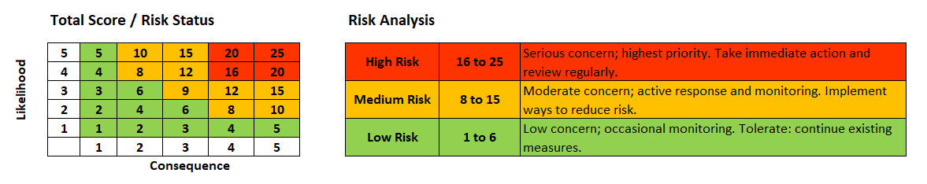
Likelihood
The chances that the hazard will adversely affect operations. How likely is it that a risk will occur or reoccur?
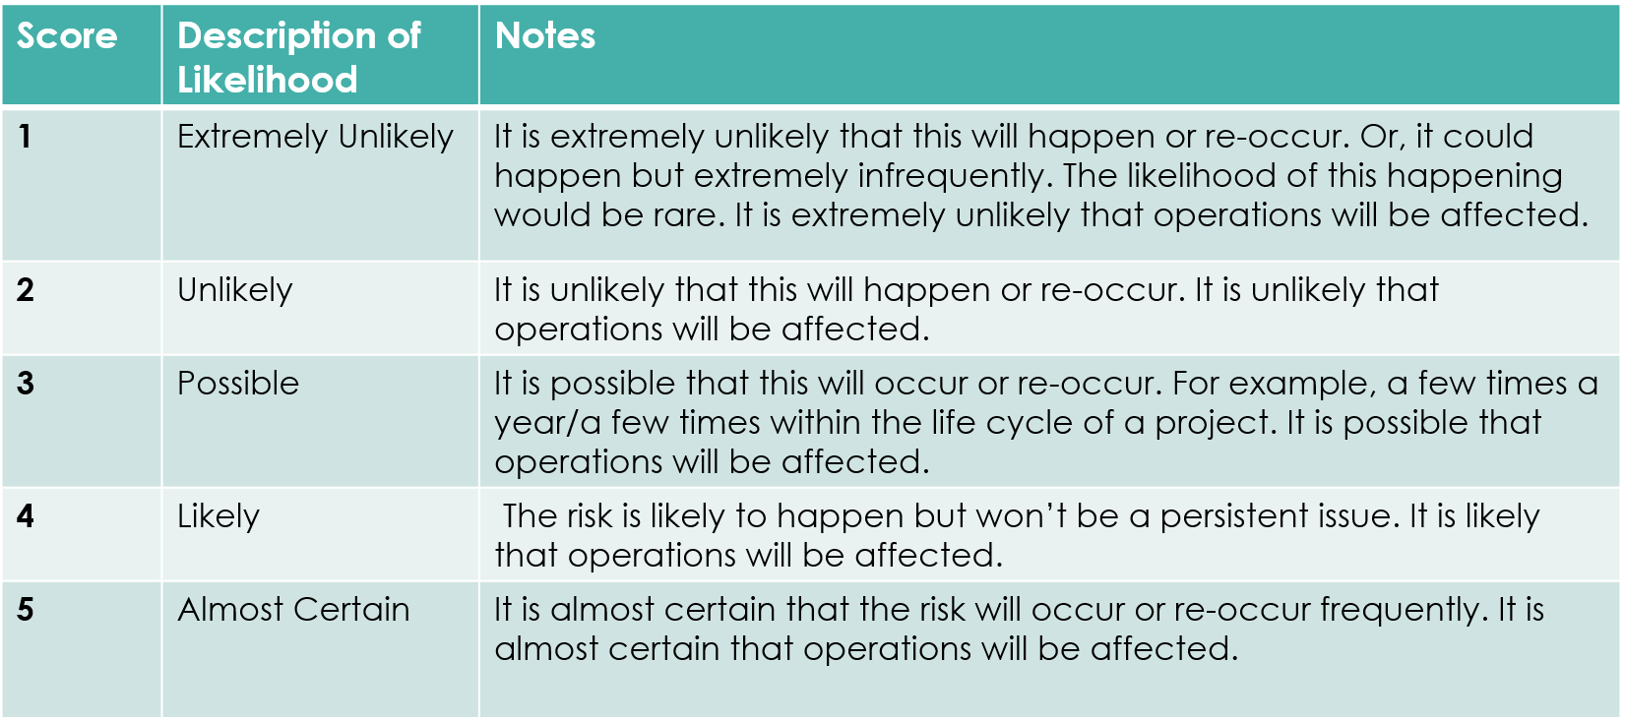
Consequence
The consequences of the hazard adversely affecting operations.

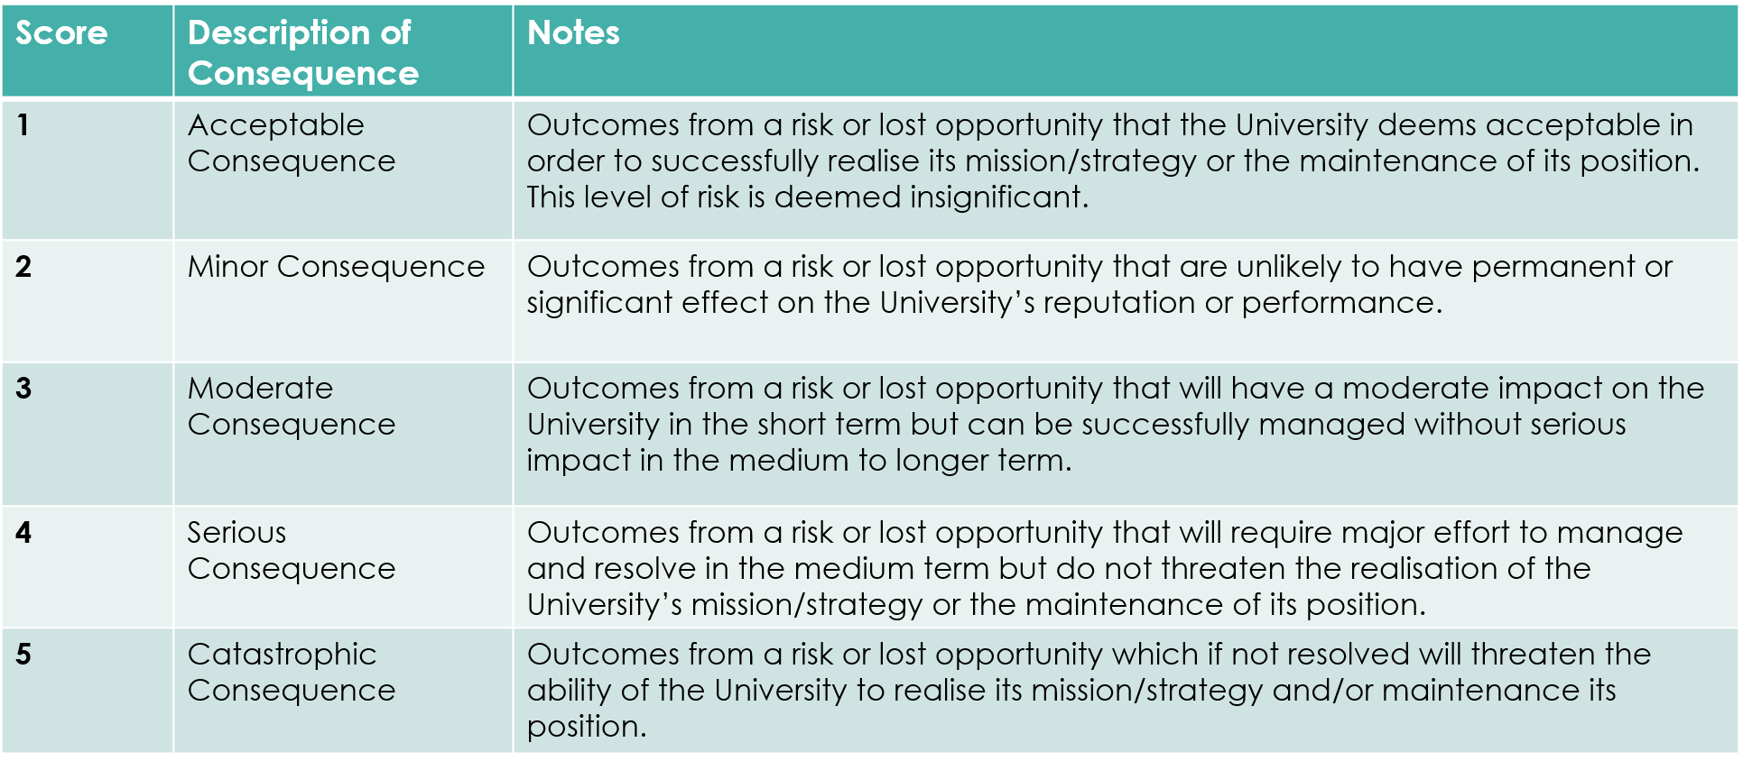

3.2 Export Controls
Please confirm whether the proposed arrangement will be subject to legislation such as export controls, Nagoya etc, and if so that the necessary advice has been taken. Guidance can be found at
https://www.liverpool.ac.uk/intranet/research-support-office/help/guides/trusted-research/

SECTION FOUR

ENDORSEMENT OF THE BUSINESS CASE

For the Dean of School / Institute

I confirm that I am satisfied with the content of this proposal, and that the appropriate off campus risk assessment processes have been undertaken.

Guidance on Off Campus Activities can be found below
https://www.liverpool.ac.uk/intranet/safety/guidance/offcampusactivities/#info

Name & Position:

Signed:

Date:

For the Faculty EPVC/Faculty Director of Operations

I confirm that I am satisfied with the content of this proposal, and that the appropriate off campus risk assessment processes have been undertaken.

Guidance on Off Campus Activities can be found below
https://www.liverpool.ac.uk/intranet/safety/guidance/offcampusactivities/#info

I confirm the Faculty will commit the financial resources to this initiative where a need has been identified above.

Name & Position:

Signed:

Date:

Appendix 1: Costing Guidelines

The following are potential costing parameters that are used for academic partnership arrangements. Examples of the activity required for partnership arrangements are shown and those who are responsible for or involved in the activity. Consideration should also be given to the workload implications for those responsible or involved in each activity and how this may impact on resource requirements and/or the time required to develop and approve the proposal.

Not all of the activity below will apply to every partnership.

Activity | Responsibility
FIRST STAGE OF APPROVAL

Putting together proposal (Forms A and B) | Proposer
Due Diligence Inquiries | Proposer
 | AQSD/PGR Team/IDO
Costings | Faculty
Head of School/Institute consideration | Dean of School/Institute
Faculty Senior Management Group consideration | FSMT
Off Campus Risk Assessment | Proposer / Dean of School / Institute
Due Diligence Panel Scrutiny | Due Diligence Panel
Senior Leadership Team  Approval of Forms A and B | SLT
PARTNERSHIP ARRANGEMENT DEVELOPMENT AND APPROVAL

Development of academic programme | Proposing School
Internal review of Programme Documentation | Faculty/CPC/School
External review of programme | Faculty/AQSD
Programme approval/validation | CPC/AQSC/UAP
Institutional / School Visit Preparation  Preparation of agendas  Liaison with partner  Establishing a panel  Travel and accommodation administration  Pre-Visit Meeting  Reviewing documentation/establishing lines of enquiry | AQSD/School
Institutional / School Visit | Panel and Secretary
Writing Visit Report/Liaising with Panel and Partner overview report | AQSD/Panel
Establishing Quality Framework/Regulations | AQSD (and others)
Negotiating and Developing Agreements | AQSD (and others)
Flights/Visas | Department / AQSD
Transfers/hotels/subsistence | Department / AQSD
MANAGING PARTNERSHIP (annual costs)

External Examiners | Faculty/School/Institute
External Consultants (if UoL has not got subject expertise) | Department
Boards of Examiners | Department/School
Annual Monitoring Visit | Department
Annual Monitoring (paper based) | Department
Moderation of Assessment | Department
Link Tutors | Department
Management of arrangement | Department
RENEWAL OF PARTNERSHIP (DURING 5TH YEAR OF OPERATION)

First stage approval and partnership approval as detailed above | AQSD

