University of Liverpool
Computing Services
Accessibility Software
A Guide for Staff and Students
Document 017
August 2011

**August 2011**

**Accessibility Software**

**A Guide for Staff and Students**

**Document 017**

**What is Available?**

This document provides details of accessibility software provided by the University.

The following list of software is available on the Managed Windows Service:

**JAWS** — Screen Reader

**SuperNova** — Screen Reader & Screen Magnifier

**ZoomText** — Screen Magnifier

**MindGenius** — Mind Mapping

JAWS and SuperNova are available in all CSD Teaching Centres. In some Teaching Centres both items have been preinstalled on alternate PCs in each Centre. Unfortunately the two applications do not get along, so they are installed on alternate PCs. To identify which PC has which application installed, you can consult the label affixed to the desk showing the PC name, e.g. BHUA-04. JAWS will be installed on odd-numbered PCs, and SuperNova on even-numbered PCs. If either of these items of software is not installed in the centre you are working in then they are available for install from the Install University Applications icon on the desktop.

Members of staff can install all of the above software on any PC connected to the Managed Windows Service via the Install University Applications icon on the desktop.

**JAWS**

JAWS for Windows Logo

**What is it?**

JAWS is a screen reading programme that reads aloud everything on the PC screen.

It can be installed on any Managed Windows Service PC. It is also available to download onto a USB Pen, which means that you can carry it around with you and use it on any PC.

If JAWS is not preinstalled on your PC then please follow the instructions below to install it:

* Double click on the **Install University Applications** icon on the desktop and select the **Accessibility** category.
* To install JAWS on your PC, select

**JAWS 11.0** **Install**

then click on the **Install** button at the bottom of the screen.

* Please note that this installation will reboot your PC so ensure all work is saved prior to installation!

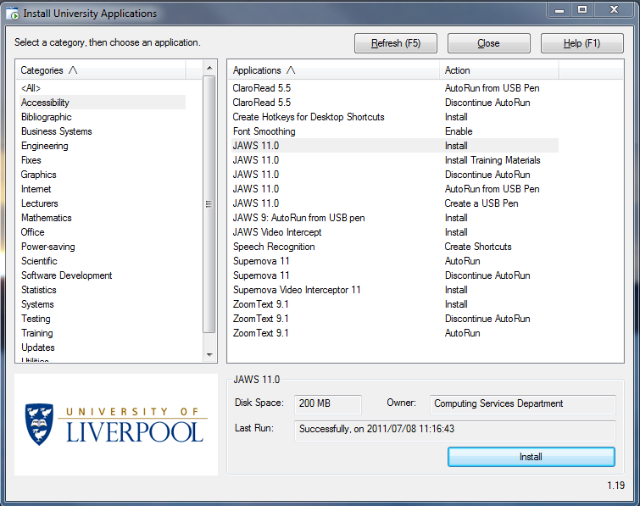

* To install Jaws to a USB pen, select

**JAWS 11.0 Create a USB Pen**

then click on **Create a USB Pen** at the bottom of the screen.

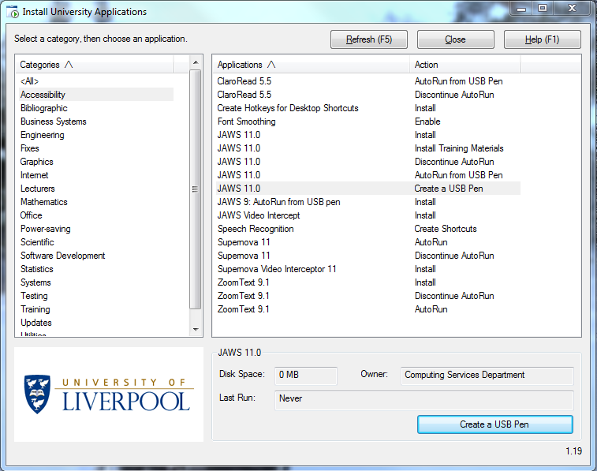

* You will then see the following screen:

Creating a USB pen of JAWS 11...
This process will install a portable version of JAWS 11 onto a USB pen, which you can then use to run JAWS on any Windows computer.
About 100 megabytes of free space will be needed on the USB pen. 
If you DO NO want to continue with creating a portable JAWS USB pen, press Ctrl+C now.
Press any key to continue...

* Press any key to continue.
* Follow the instructions on screen. You will be instructed to insert your USB Pen.
* You will need to know what drive letter the USB pen is on. Open Windows Explorer and identify the drive letter. Enter this when requested.

Please insert a USB pen, if you hve not already done so.
You will need to know what drive letterthe USB pen is on.
Press a key when you are ready to continue.
Please enter the drive letter of your USB pen: E
Copying. This takes about one minute.

* It will take about one minute for the program to copy to the pen. The light on the USB stick will flash and the window above will stay on screen whilst the copying is in progress.
* When you have created your USB Pen, the following web page will open giving you details on how to use JAWS via your USB pen.

<http://pcwww.liv.ac.uk/csd/accessibility/autorun-jaws.html>

* Please note that if you wish JAWS to start automatically you will also need to install JAWS AutoRun from USB Pen. Click on

**JAWS 11 AutoRun from USB Pen**

then click on **AutoRun** at the bottom of the screen.

* If you prefer JAWS not to start up automatically, double click on the Install University Applications icon on the desktop and select the Accessibility category.
* Click on

**JAWS 11.0 Discontinue AutoRun**

then click **Discontinue** **AutoRun**.

**SuperNova**

Dolphin SuperNova Logo

SuperNova is both a screen reader and screen magnifier.

A combined screen reader and magnifier allows you to increase magnification or add the speech function, as eyes become tired or vision deteriorates.



SuperNova can read aloud as you type, announcing words or characters so that you can check them as you are typing.

SuperNova and JAWS are not compatible alongside each other on Windows 7 — it is advisable to only have either of these installed at any given time.

To install SuperNova please follow the instructions below:

* Double click on the Install University Applications icon on the desktop and select the Accessibility category.
* To install SuperNova on your computer, select

**SuperNova Video Interceptor 11 Install**

then click on **Install** at the bottom of the screen.



* Please note that if you wish SuperNova to start automatically on login you will also need to install SuperNova AutoRun. Click on

**SuperNova 11 AutoRun**

then click on **AutoRun** at the bottom of the screen.

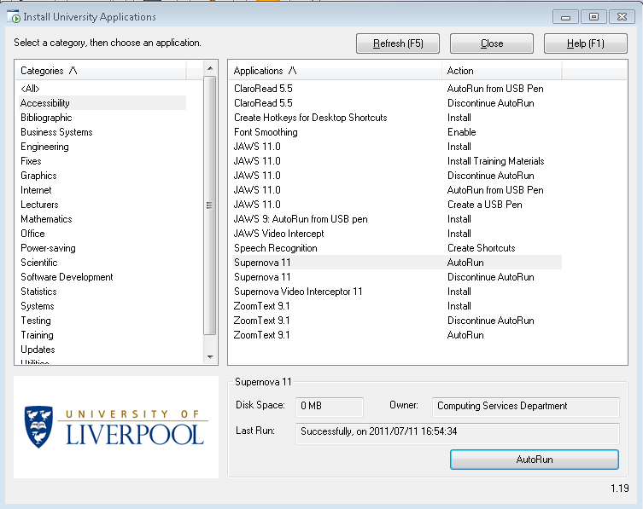

Once installed, SuperNova will run automatically on your PC.

* If you want to stop SuperNova automatically starting, double click on the **Install University Applications** icon on the desktop and select the **Accessibility** category.
* Click on

**SuperNova 11 Discontinue AutoRun**

then click **Discontinue** **AutoRun**.



**ZoomText**

ZoomText is a screen magnifier. You can magnify your screen to more easily view your applications and documents.

To install ZoomText please follow the instructions below:

* Double click on the Install University Applications icon on the desktop and select the Accessibility category.

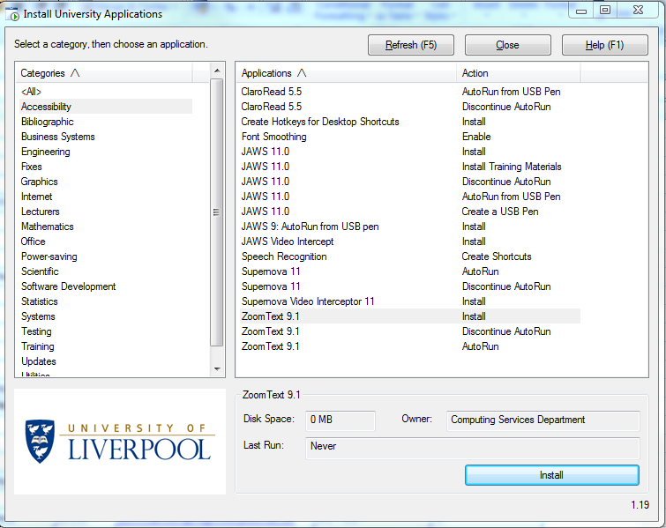

* To install **ZoomText** on your computer, select

**ZoomText 9.1 Install**

then click on **Install** at the bottom of the screen.

* Please note that if you wish to start ZoomText automatically on login you will also need to install ZoomText AutoRun. Click on

**ZoomText 9.1 AutoRun**

then click **AutoRun** at the bottom of the screen.

Once installed, ZoomText will run automatically on your PC.

* If you want to stop ZoomText automatically starting, double click on the **Install University Applications** icon on the desktop and select the **Accessibility** category.
* Click on

**ZoomText 9.1 Discontinue AutoRun**

then click **Discontinue** **AutoRun**.

MindGenius 3 Logo**MindGenius**

MindGenius is a graphical mind mapping software which will help get your ideas out of your head and onto paper.

Mind mapping is an alternative to linear thinking and traditional note–taking. It can help your creativity and represents your thoughts more visually.

Mind maps use different map layouts depending on the task e.g. family tree, brainstorming, organisational charts etc.

The figure below is an example of a Mind Map.

Example map from MindGenius

**Benefits and Uses**

A Mind Map can:

* Give an overview of a large subject;
* Enable you to plan routes or to make choices, and will let you know where you are going and where you have been;
* Gather together large amounts of information in one place;
* Encourage problem solving by allowing you to see new creative pathways;
* Be enjoyable to look at, read, muse over and remember easily.

Mind maps can be used in many different contexts:

* Note taking
* Brainstorming (individually or in groups)
* Problem solving
* Studying
* Planning
* Researching and consolidating information from multiple sources
* Presenting information
* Gaining insight on complex subjects

To install MindGenius follow the instructions below:

* Double click on the Install University Applications icon and then select the Utilities category.
* Click on

**MindGenius** **Install**

then click on **Install.**

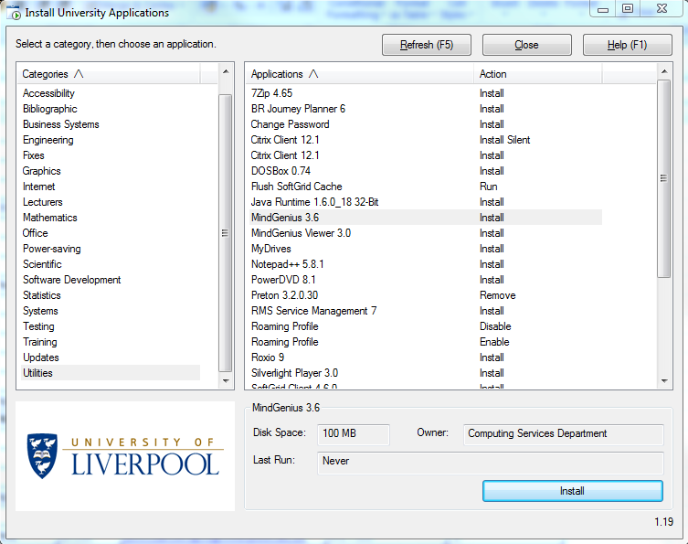

**Further Information**

If you need further help or advice on accessibility software, please contact the CSD Service Desk on   
0151 794 4567 or email [servicedesk@liverpool.ac.uk](mailto:servicedesk@liverpool.ac.uk).

For further accessibility advice, you can contact the following:

<http://www.liv.ac.uk/csd/accessibility/>

<http://www.liv.ac.uk/csd/pccentres/facilities.htm>

<http://www.liv.ac.uk/studentsupport/disability/>