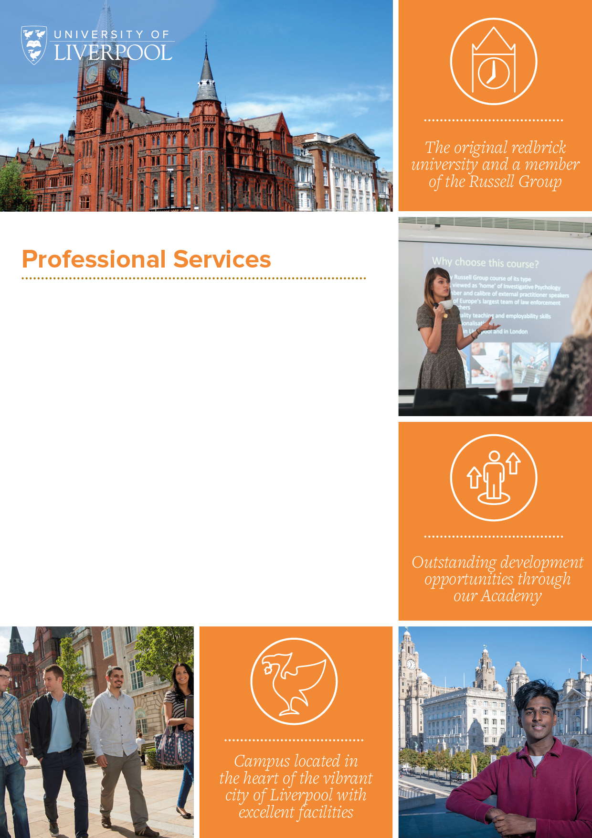

**Residential Advisor**

**(Casual Employee)**

**Area:** Directorate of People and Services. Facilities, Residential and Commercial Services. Residential Services Department.

**Location:** University Campus and Greenbank Student Village

**Residential Advisor Remuneration:** University accommodation free of charge

**Working Hours:** Hours will be directed by the Hall Warden and will include overnight duty rota during term time and non-term time at evenings and weekends as necessary.

**Tenure:** Not permanent and reviewed annually

*Online application> Shortlisting > Interview Process> Job Offer*

**Role overview and University context:**

* The Residential Adviser is line managed by the Hall Warden and is also responsible to the Head of Accommodation.
* The Residential Adviser is required to reside within the designated University accommodation
* The Residential Adviser will also work closely with several Halls teams and staff, who will on occasion direct tasks the Residential Adviser needs to undertake. These include Halls Management, the Halls Life Team, the Accommodation Manager and the Halls’ Student Experience Manager.

**Responsibilities:**

* To thoroughly read through the Residential Advisor handbook and student conduct policy and procedure and use as part of delivery of duties including a schedule of check in flat talks
* As part of a Duty Rota, to provide an overnight on-call service to students within their hall and be a first responder to any incidents that may occur. This Duty Rota will include vacation and summer periods and may include cover for a group of University accommodation
* As part of being a first-responder, where a student related incident is serious, this must be escalated to Campus Support in the first instance who may then escalate to the Residential Services on-call rota and the Hall Warden
* All student related incidents (welfare and discipline) including flat talks to be recorded on Student Life same day or next day
* To provide pastoral support to a cohort of students and make regular contact with these students and in accordance with the schedule as provided by the Residential Advisor Handbook and will include fire safety, health and safety where appropriate to do so. In addition, attendees and check in chat discussion to be recorded on student life
* To support student move in, in collaboration with Halls Management, Accommodation and the Hall Warden
* To carry out welcome chats with the designated student cohort and must include orientation of hall, fire safety, health and safety, student safety, key contacts and other useful information as directed by the Hall Warden and Halls Life team and to record attendance and content on student life
* Generally, to advise students on straightforward matters concerning welfare and to direct students to appropriate specialist advice services provided by the University or external organisations including Health Assured
* To assist with the smooth running of arrivals weekends. Depending on the cohort of students within the Hall, this may include arrival periods across the year for Postgraduate, Undergraduate, Study Abroad and Pre-Sessional Students, or other groups, as relevant.
* To support the promotion and delivery of activities organised for the Hall by the Halls Life Team or Hall Student Committee, including staffing events.
* To organise events and activities for your own group of students at regular intervals across the year, with advice and support from the Halls Life team.
* To assist the Halls Life Team in raising awareness of relevant extracurricular opportunities available to Halls students, including sporting opportunities provided via Sport Liverpool.
* To promote and maintain an atmosphere where student residents can enjoy themselves while respecting others’ rights to peace and quiet.
* To encourage respect for the University/Hall property and the environment.

**Duties:**

* To attend the annual Residential Advisor Conference, normally held in September each year
* To commit to further training mandatory and non-mandatory as part of continuing professional development programme
* To ensure that social spaces within the hall are used appropriately.
* To assist with the 6 monthly Student Fire Alarm Evacuation Drills (where applicable) with the Hall Warden and Hall Manager
* To support the Hall Warden when requested to undertake note taking during local disciplinary action meetings
* To undertake specific additional duties to assist with the smooth running of the Halls as instructed by the Hall Warden
* To maintain excellent working relationships with Hall Management, Halls Life, Accommodation Office, Campus Support, Student Support and other University staff and departments
* To undertake other duties and responsibilities where appropriate and as assigned by the Warden or the Head of Accommodation or designate therein
* To be aware of own well-being including mental health wellbeing and seek advice and/or support where appropriate to do so

**In addition to the above, all University of Liverpool staff are required to:**

* Adhere to all University policies and procedures, completing all obligatory training and induction modules, including Equality & Diversity and Health & Safety.
* Respect confidentiality: all confidential information should be kept in confidence and not released to unauthorised persons.
* Participate in the University’s Professional Development Review scheme and take a proactive approach to own professional development.
* Demonstrate customer service excellence in dealing with all stakeholders.
* Embody and uphold the University’s Vision and Values.

|  |  |  |
| --- | --- | --- |
| **Essential Criteria** | | **Desirable Criteria** |
| **Experience** | | |
| 1.1 | Either a registered student (or prospective student) of the University of Liverpool, or a current member of University staff | Working knowledge and experience of University computer systems e.g. Agresso, Tulip |
| 1.2 | Experience of providing a pastoral service to resident students including discipline, welfare and student engagement and activities | Working knowledge and experience of University student case management system Student Life |
| 1.3 | Experience and understanding of delivering a customer focussed service and working closely with key partners such as Halls Management, Student Services and Campus Support |  |
| **Education, Qualifications and Training** | | |
| 2.1 | 3 GCSE’s at Grade C or above (or equivalent) including English Language and Mathematics | Coaching and mentoring |
| 2.2 | Supervisory leadership training or equivalent | Mental health first aid |
| **Skills, General and Special Knowledge** | | |
| 3.1 | Computer literate with knowledge of E-mail, Microsoft Word and Excel |  |
| 3.2 | Knowledge and understanding of health and safety |  |
| 3.3 | Excellent interpersonal and communication skills both verbal and written |  |
| **Personal Attributes and Circumstances** | | |
| 4.1 | To be able to deal with confidential matters with discretion | Interest in event creation, organisation and/or management |
| 4.2  4.3 | Ability to react positively to situations and problems and especially those necessitating emergency or immediate student support in relation to student incidents including welfare. |  |
| 4.4 | Approachable and able to build positive relationships with others |  |
| 4.5 | Empathetic with excellent listening skills |  |
| 4.6 | Reliable with the flexibility to be on call overnight and work weekends |  |
| 4.7 | Ability to work well under pressure |  |
| 4.8 | Able to work independently without supervision and take appropriate decisions within the scope of the role |  |
| 4.9 | Resilient and proactive in managing own wellbeing |  |
| 4.10 | Able to work well as part of a team |  |
| 4.11 | Willing to undertake training and update own knowledge |  |
| 4.12 | Able to assist with rota cover out of term time (Christmas, Easter and Summer vacation periods) |  |

Established in 1881, we are an internationally renowned Russell Group university recognised for our high-quality teaching and research. We are consistently ranked as one of the best Universities both nationally and globally, and the majority of our research is rated world leading or internationally excellent. Find out more [here](https://www.liverpool.ac.uk/about/).

**Our Areas**

When you work at the University of Liverpool you are more than just your job role. You are a crucial part of our mission to improve lives on a local, national and international scale.

**Why Work Here**

We recognise, appreciate and celebrate the incredible work our staff do every day. As well as generous terms and conditions, we offer a range of enviable benefits and provide support for colleague’s wellbeing and development. Discover more [here](https://www.liverpool.ac.uk/working/whyworkhere/).

**Moving from abroad**

As a global institute, we welcome applicants from all nationalities, moving from a different country can be challenging and we would like to help as much as we can, we have put together some information on eligibility to work documentation, accommodation, schools, healthcare, life in Liverpool and the UK as well as other practical information. Discover more [here](https://www.liverpool.ac.uk/working/relocating/).

**Our Staff**

Whether it be their friendly colleagues, supportive managers or our outstanding facilities, our staff can explain better than anyone what it is like to work for us and why they enjoy their role. See what they have to say [here](https://www.liverpool.ac.uk/working/whyworkhere/colleagues-stories/).

***The University of Liverpool is committed to being an inclusive employer. We welcome applications from everyone regardless of age, gender, ethnicity, sexual orientation, faith or disability.***

**Contacting us**

**Application process**

Our e-recruitment system enables you to register for an online account, where you can view, copy and edit your applications. Set up your account [here](https://my.corehr.com/pls/ulivrecruit/erq_search_package.search_form?p_company=1&p_internal_external=E).

Once you submit your application you will receive an automatic email acknowledgment.You can view your application any time by clicking into the application history section of your account.

**Job Description**

After the closing date this job description will be removed from our website. Should you wish to refer to this information at a later date please ensure you save a copy of this document.

**Right to work**

We have a legal responsibility to ensure that you have the right to work in the UK before you can start working for us. If you do not have the right to work in the UK already, any offer of employment we make to you will be conditional upon you gaining it. The UKVI have an interactive tool allowing you to immediately see if vacancies are eligible for a Skilled Worker visa. You will need to know the SOC code for the role, our most used SOC codes can be found [here](https://www.liverpool.ac.uk/intranet/media/intranet/humanresources/2014/recruitment/Check,if,a,job,role,is,potentially,eligible,for,a,skilled,worker,visa.docx), if none of these apply to this role, there are more codes on the eligibility checker. The skilled worker eligibility checker can be found on [GOV.UK](https://www.gov.uk/government/publications/uk-points-based-immigration-system-employer-information/the-uks-points-based-immigration-system-an-introduction-for-employers).

**Disabilities and alternative formats**

If you have any other requirements which will help you access the application or interview process or employment opportunities at the University, or if you require copies of documentation in alternative formats, please email: jobs@liverpool.ac.uk or telephone 0151 794 6771.

**Outcome of your application**

The recruiting department will endeavour to respond to each application. However, if you have not heard within six weeks of the closing date, please take it that your application has not been successful on this occasion.

cid:image006.png@01D8144E.E2C426A0cid:image002.png@01D8144E.E2C426A0